Frozen Banana Pops
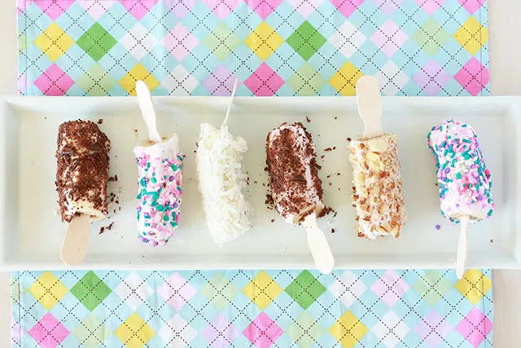

Prep Time: 10minutes minutes
Freezing Time: 2 hours
Servings 6 pops
Ingredients

3 medium bananas
1 cup yogurt
1 cup toppings of choice shredded coconut, chopped nuts, sprinkles, mini chocolate chips, peanut butter drizzle, crushed pretzels
Instructions

Peels bananas and cut in half. Place a popsicle stick in the end of each banana half and insert about halfway into the banana.
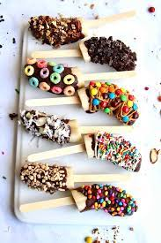
Lay bananas on a baking sheet with a piece of parchment.
Freeze for about an hour. Dip each banana into yogurt and then roll into the toppings (you can also dip in melted chocolate if preferred ⏩
Place back on the baking sheet and freeze for another hour. If you want to store them longer, place in an airtight container and enjoy for up to 2-3 months.

